**Lab: Route 53 with CloudFront**

**Services Used: Route53 & CloudFront**

1. Verify you have already setup cloudfront distribution and it is deployed and enabled.

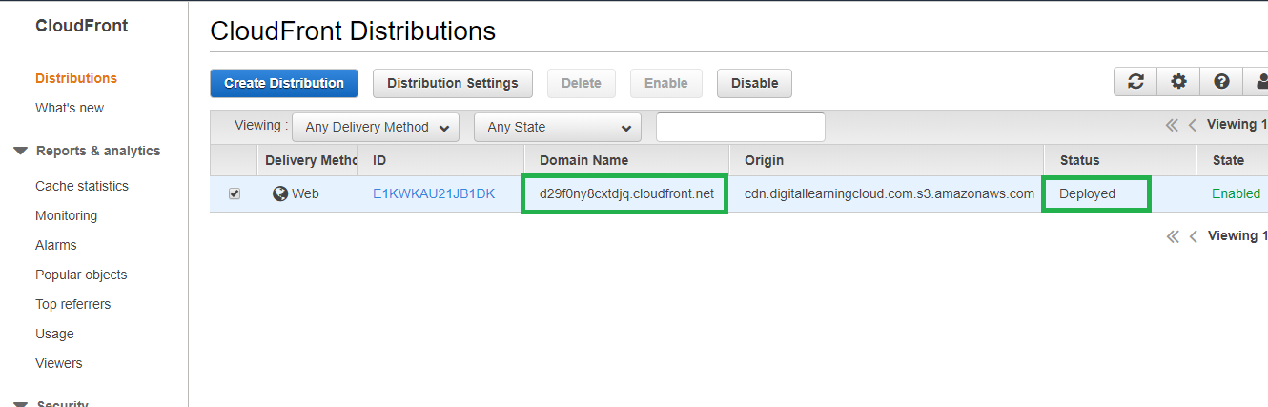

1. Verify the cloudfront accessibility over internet and it is working fine.

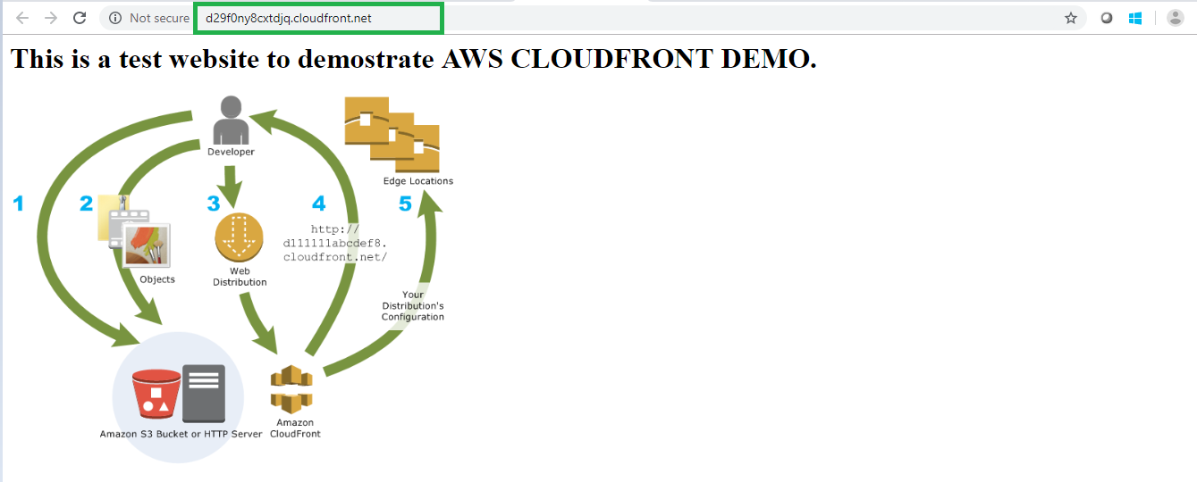

1. Edit the cloud front distribution and configure the cname that you want to use for configuring in Route 53.

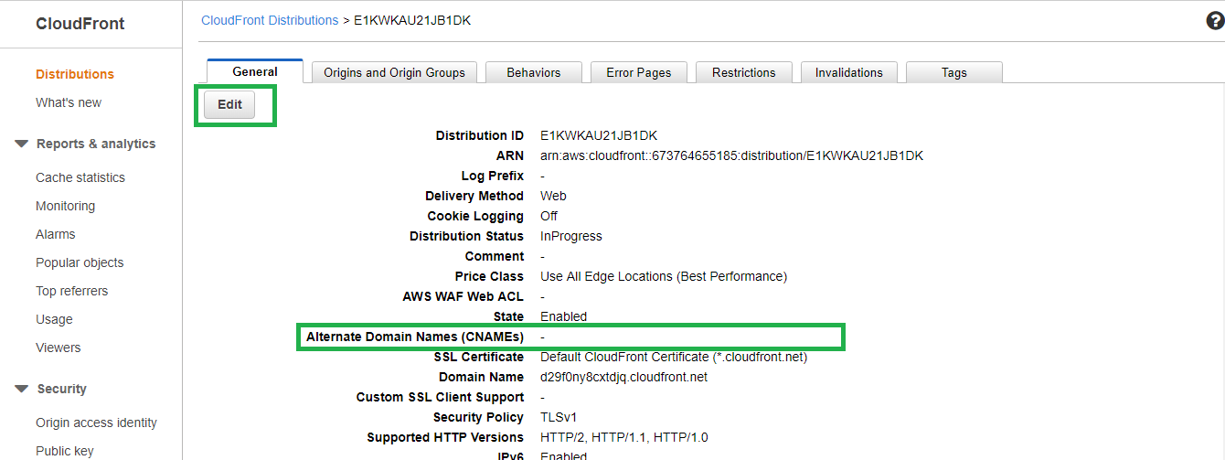

1. In this example we are configuring the cloudfront distribution to be configured in route 53 as cdn.digitallearningcloud.com. So we have provided cname as cdn.digitallearningcloud.com.
2. Select the SSL certificate issued for cdn.digitallearningcloud.com. [Refer Certificate creation lab for this]

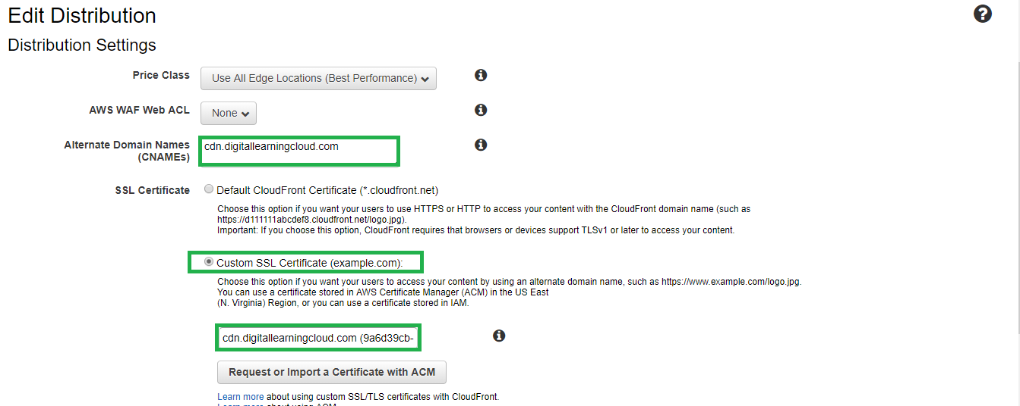

1. Keep the remaining default settings as it is and provide default root object as index.html which his configured.

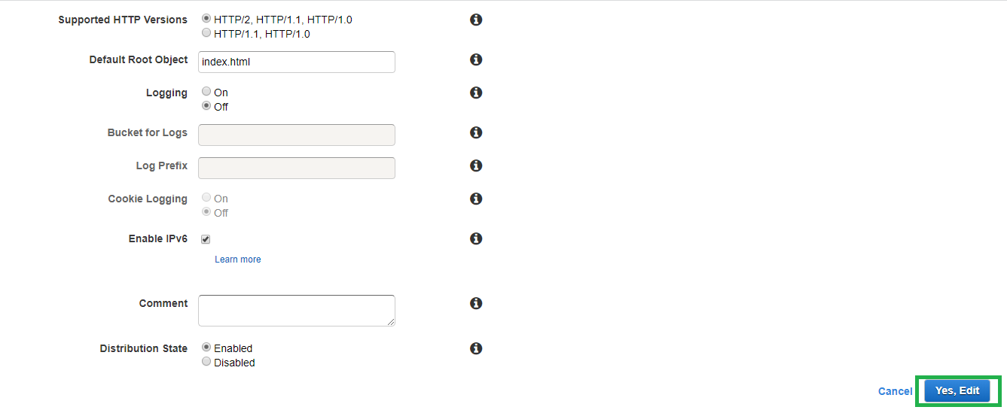

1. Click yes, edit to push the changes. The distribution changes will be pushed across.

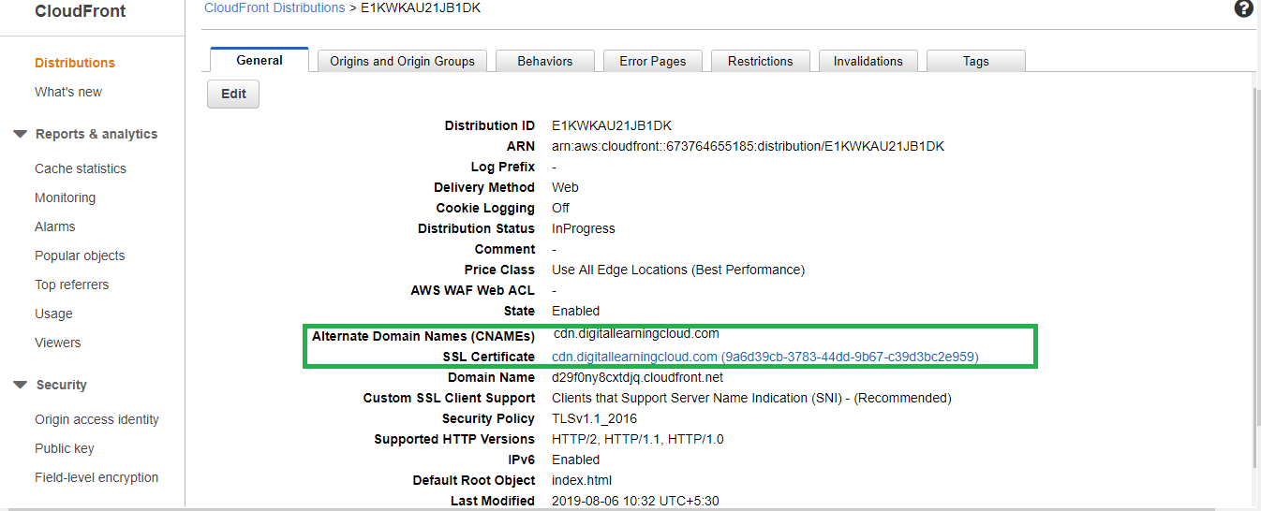

1. Verify the cname is now reflecting in the cloudfront configuration.

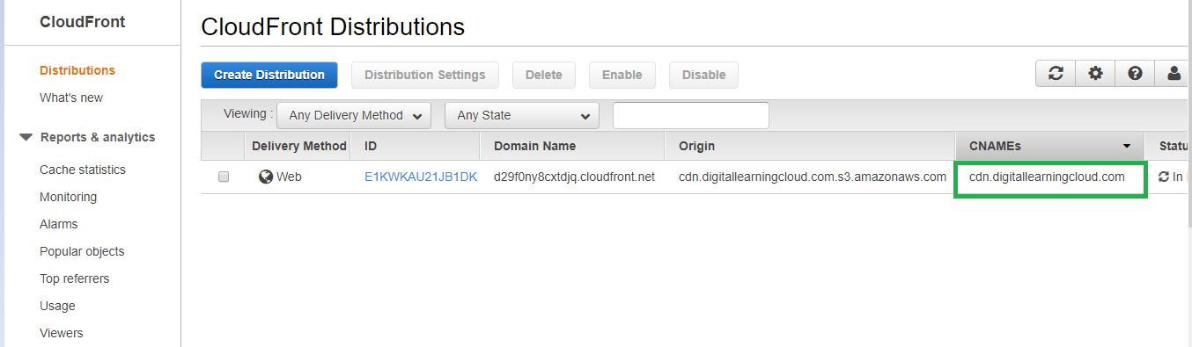

1. However the site is still not accessible with this cname as route53 record creation is still pending.

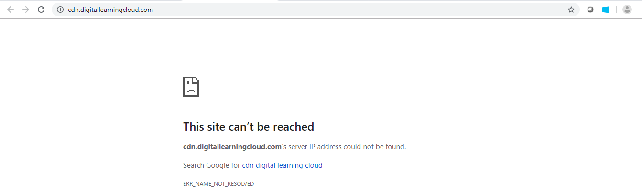

1. Go to Route53 service and select the domain name hosted zone.
2. Click create record set to add record for the cloud front distribution.

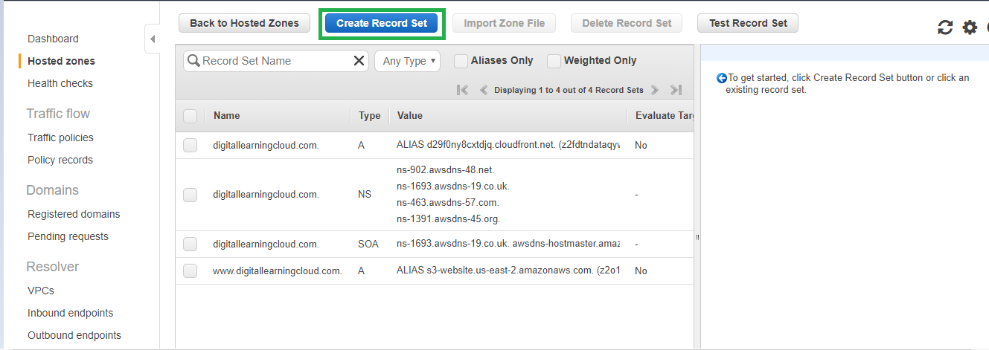

1. In the create record set provide the name as cdn and click alias and select the listed cloudfront distribution which we have already configured.

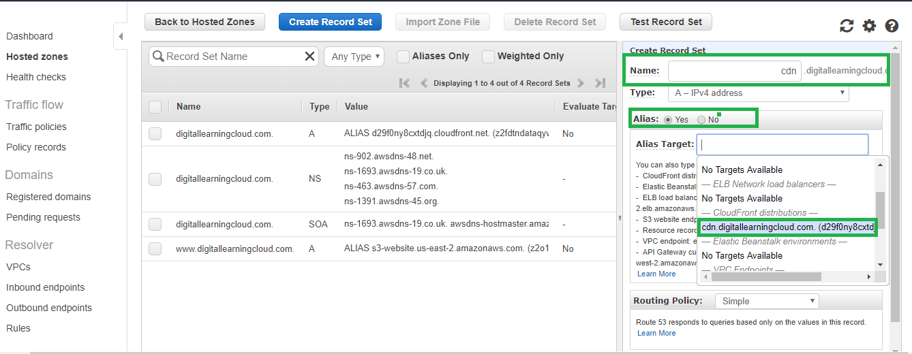

1. Keep the policy as simple and click create.

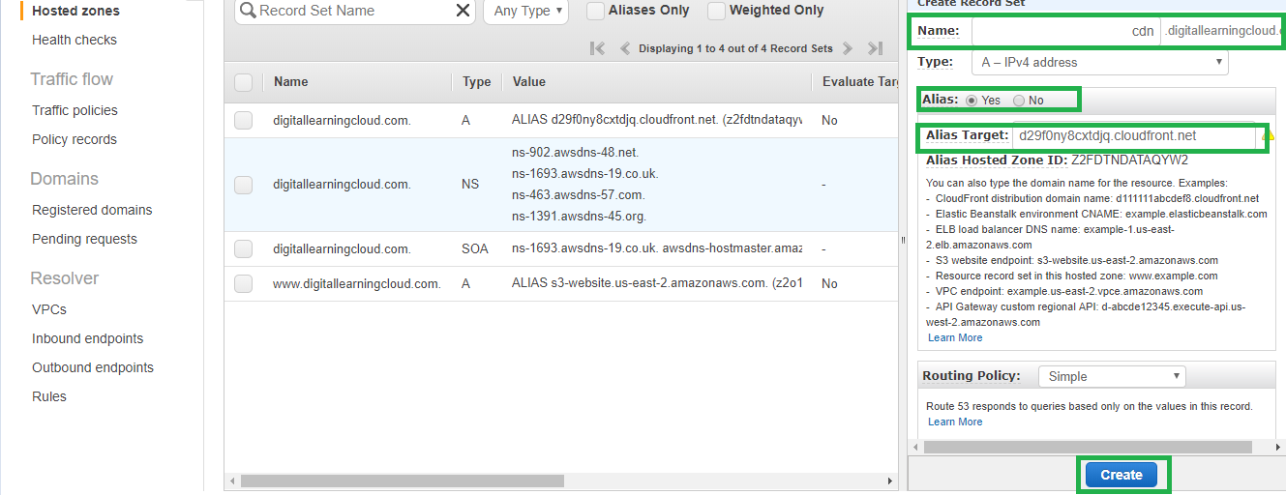

1. Verify that the record is added.

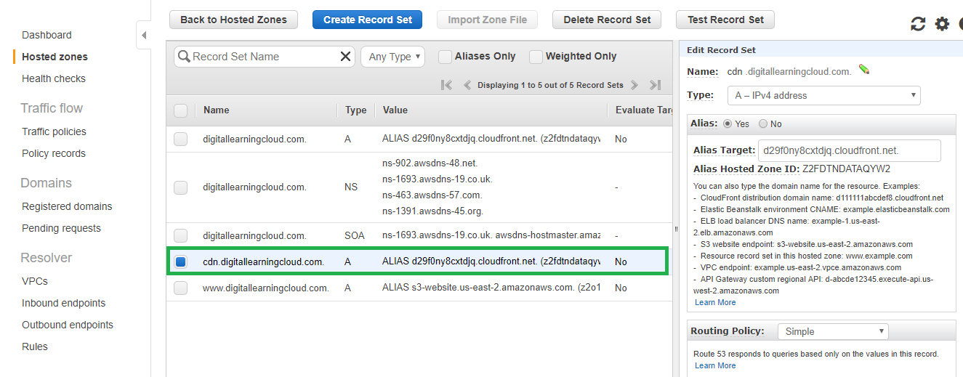

1. Validate the cloud front distribution is now accessible with the route 53 record cdn.digitallearningcloud.com

